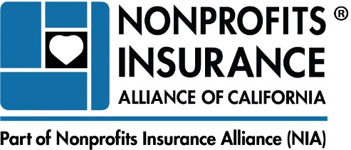 www.insurancefornonprofits.org

NIAC
Animal Questionnaire

Applicant Name:
Contact Person: |  | Member Number:
Billing Address:

Animals
1. | Does Applicant have any exposures involving animals? | Yes No
 | What Kind:
2. | Does Applicant have any saddle animal operations? | Yes No
 | If yes, please answer the following:
 | a. Are animals used solely for therapeutic purposes? | Yes No
 | If no, explain other usage:
 | b. Are safety helmets required? | Yes No
 | c. Are animals: Owned by Applicant Furnished to Applicant by third party | Yes No
 | d. Number of animals owned by or used by Applicant:
3. | Does Applicant provide animal shelter/rescue services? | Yes No
 | If yes, please indicate the number of:
 | a. Spaces, cages or kennels on Applicant’s premises available to house animals:
 | b. Animals placed in foster care annually:
 | c. # dog foster homes # cat foster homes # other foster homes
 | d. Offsite adoptions held annually:
 | e. Are all animals vaccinated and held for observation prior to being placed in any homes (adoptive or foster)? | Yes No
 | f. Is a health assessment of the animal conducted by a professional qualified to assess communicable disease? | Yes No
 | g. Are behavioral evaluations performed by a qualified professional of all animals prior to placement (foster or adoption)? | Yes No
 | h (i). Does the Applicant accept “Aggressive Animals” to their program or place “Aggressive Animals” into homes (foster or adoption)?  If yes, please describe your procedure before accepting or placing the animal in a foster or adoptive home  h (ii). If an animal not previously thought to be an “Aggressive Animal” is subsequently discovered to be an “Aggressive Animal” after entering your program, will you remove that animal from your program (i.e. no longer foster it out, make it available for adoption or keep custody of it)?  “Aggressive Animal" means any animal, which is known to have been:  - responsible for inflicting “severe injury” on a human being or animal on public or private property;  - previously under investigation and deemed to be dangerous by animal control and/or local authorities; or  - surrendered with a known history of biting resulting in “severe injury” or other violent behavior by the prior owner or a governmental entity, notwithstanding any subsequent finding to the contrary by you, an insured, by any other person for whom an insured is legally responsible or by an animal behavioralist.  “Severe injury” means any physical injury that results in death, bleeding, muscle tears or disfiguring lacerations or requires multiple sutures or corrective or cosmetic surgery. | Yes No  Yes No
 | i. Are waivers for volunteers of adoptive/foster homes maintained and do they include hold harmless language that specifically discloses that the animal may cause bodily injury to the volunteer, and that the volunteer will not hold the nonprofit responsible for any injury to themselves or family members that arise from the foster/adoptive relationship? | Yes No
 | j. Does Applicant have accident coverage in place? | Yes No
 | k. How long has Applicant been in business?
 | l. How many years experience does the Applicant's leadership have in this field?
4. | Does Applicant employ animal control officers? | Yes No
 | If yes, please answer the following:
 | a. How many?
 | b. Do they carry firearms? | Yes No
 | c. Do these officers carry separate professional liability insurance? | Yes No
5. | Does Applicant operate any of the following? | Yes No
 | If yes, provide annual sales for each:
 | Type Annual Sales $
 | Pet Training $
 | Pet Grooming $

